**Part 1 - Common Analysis**

**Raman SV  
8-Nov-23**

**Visualizing the aspects of the analysis**

Visual 1: Produce a histogram showing the number of fires occurring every 50 mile distance from your assigned city up to the max specified distance.

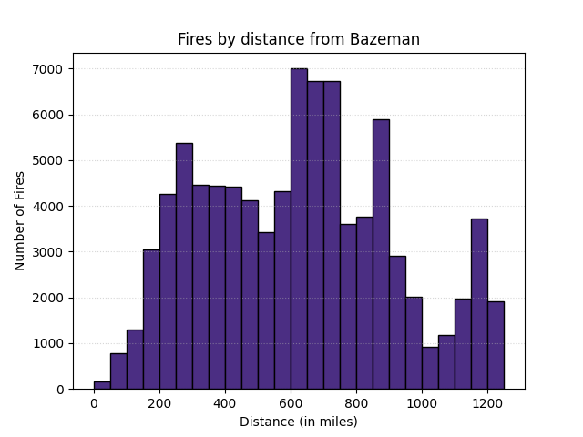

Visual 1: Fires by distance from Bozeman, MT

This visual above shows the number of fires at varying distances from Bozeman, Montana over the period of 1963-2023.

The X-axis shows the distance in miles, these are binned into incremental distances of 50 miles each. The Y-axis represents the number of fires in each of these distance bins.

As can be seen from the visual, there are very fires that are immediately in the proximity of Bozeman while the “hot” spot seems to be around the 500-900 miles distance. This would tend to make sense given the geographical location of Bozeman, a gateway city to the Yellowstone national park. It has dense forests and mountain regions to the west and south and these could contribute to the higher density of fires at this distance. A point of interest is that the Canadian border is roughly 300 miles north and while this might not be covered in the US tracking of data, this could lead to fires coming down from the north.

Visual 2: Produce a time series graph of total acres burned per year for the fires occurring in the specified distance from your city.

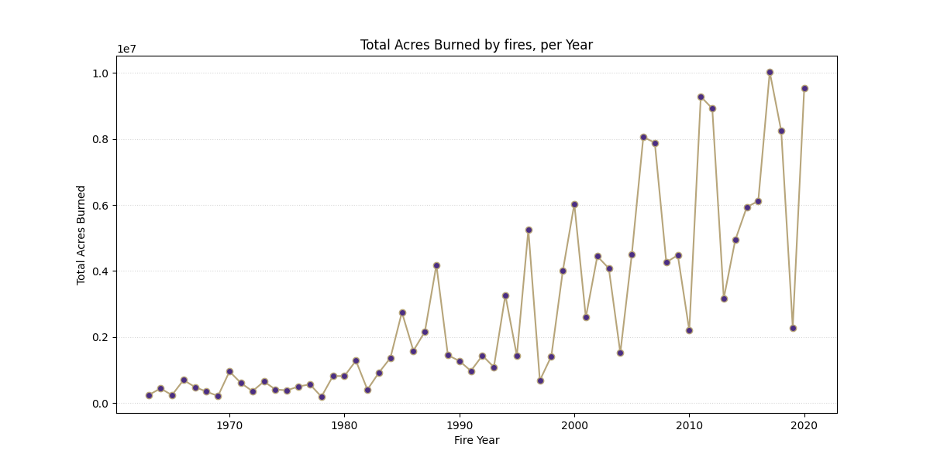

Visual 2: Total Acres burned by fires per year

This visual above shows the total number of acres burnt down by fires over the period of 1963-2023. All these are within 1250 miles of Bozeman, MT.

The X-axis shows the years, and the Y-axis represents the total acreage destroyed by fires in each of these years. It seems almost fascinating that the number of acres burned seems to be increasing exponentially over the years. One would assume that given deforestation and more urbanization, the forest area would be coming down. This would make one question what constitutes the area burnt. This could include cities or other habitations. This could also imply more drier areas leading to rapid spread of fires. Of course, there is also the increased risk due to climate change causing longer and more historic droughts in the region and this drier landscape can lead to more runway fires.

Visual 3: Produce a time series graph containing your fire smoke estimate for your city and the AQI estimate for your city.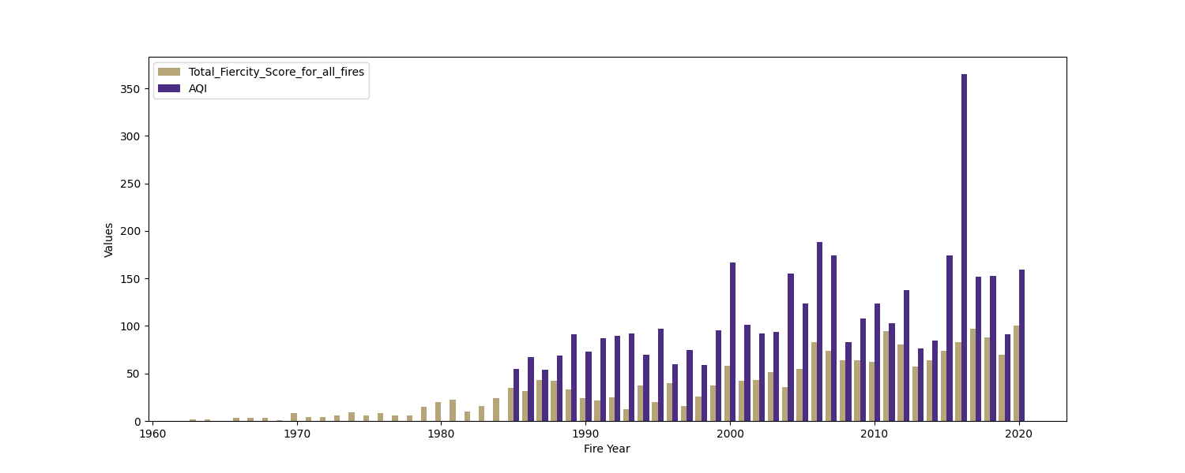

Visual 3: Comparison between the calculated “fiercity score” with the measure AQI

This visual above shows the comparison between the calculated fiercity score based on various input features and the overall AQI index over the period of 1963-2023 within 1250 miles of Bozeman, MT. The X-axis shows the years, and the Y-axis represents 2 data points for each year as bars: the predicted score and the AQI index for that year.

The AQI data starts around mid 80s and it would seem that the model directionally predicts the severity but cannot account for outliers such as the big spike around mid 2010s.

**Reflections and takeaways**

As part of this activity, I had the chance to collaborate with various classmates to get their impressions on the project, their approaches as well as open-ended discussion around cause and effect. I mostly interacted with Arjun Sharma and Adithyaa V. The conversations mainly centered around the fires in the west coast and what we felt, was the outsized attention it derives as opposed to visible impacts. We were essentially extrapolating the situation in India where “normal” AQI hovers around 100-150 in major cities and no one bats an eye. To the contrary, especially in the west coast, what would seem like just another day to us caused consternation among the locals about poor air quality and smog. This further led us to discuss topics such as cause and effect of wildfires and how the biggest impact to urban areas are around air quality and spectacular sunsets over losing houses and property. It led us to read more about the impacts of wildfires and how a sudden excess could be attributed to such weather phenomena as El Nino and overall, climate change.

On a personal level, I have always been interested in the societal impacts of climate change and the discourse is wildly opinionated on the west coast social media sites I was able to look at. There is a larger impact of climate change on our lives and while fires definitely set the heart racing, the droughts that cause the fires are probably a bigger cause for concern. Drying rivers, over populated desert cities and unbridled commercial agriculture are major factors to keep an eye out for over the next few years.

I hope to continue analyzing these topics as I move forward with other parts of this projects and I hope to be able to create inferences based on data and add context to the conversation.